Name: Justin V Kalappura
Roll No: 10
Batch: MCA
Date: 09/05/2022

NETWORKING & SYSTEM ADMINISTRATION LAB

Experiment No.: 17

Aim:
Write a shell scripting program to find the sum, product and average of given four numbers.

Procedure:
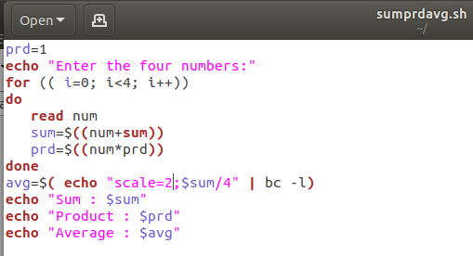

Output Screenshot:
